QA Testing Plan

1. **Feature:** User Registration

**User Flow:**

* Navigate to the Amazon homepage.
* Click on the "Start here" link to register.
* Enter personal details: name, email, password.
* Click "Create your Amazon account."
* Receive a confirmation OTP.
* Enter the OTP to activate the account.
* Add the Cell Phone number.
* Receive a confirmation OTP.
* Enter the OTP to activate the account.

**Test Case:**

* Test Plan: Use boundary value analysis to test the input fields.
* Input Fields: Name, Email, Password, Password Confirmation.
* Boundary Values: Test with minimum, maximum, and invalid lengths for name and password; check email format validation.

**Steps:**

* Enter valid data for all fields.
* Enter invalid email format and check for error message.
* Enter mismatched passwords and check for error message.
* Ensure a confirmation email is sent.

**User Registration: Automated Test script:**

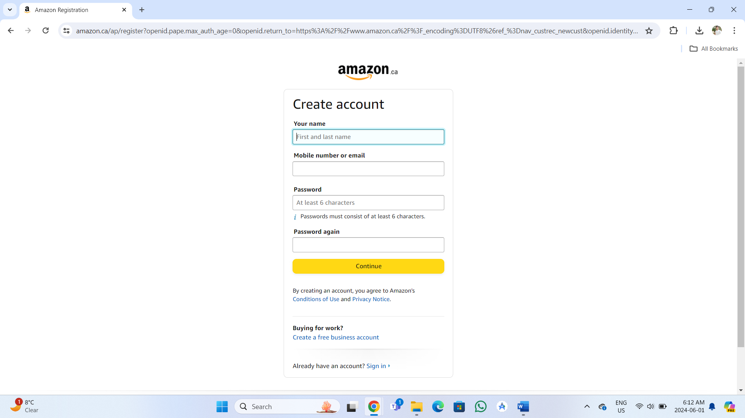 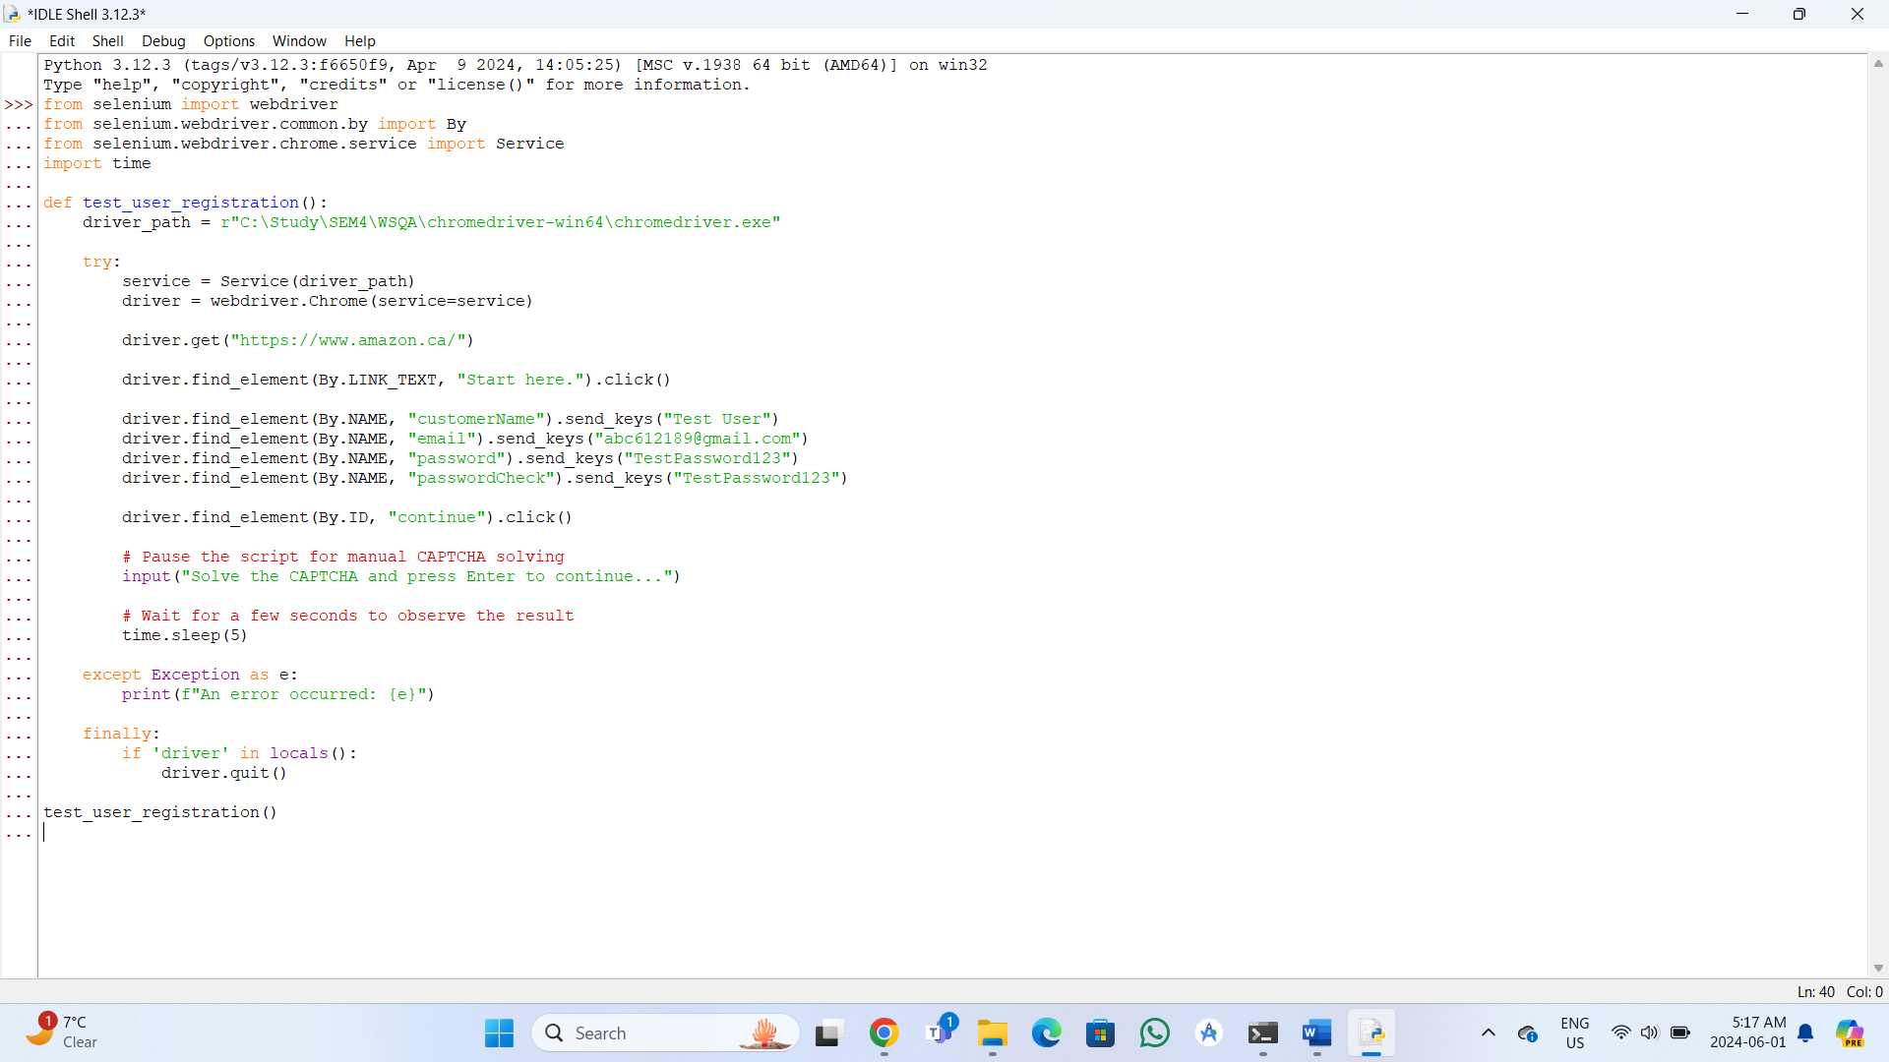

1. **Feature:** Product Search

**User Flow:**

* Enter a product name in the search bar on the homepage.
* Press "Enter" or click the search button.
* View the list of search results.
* Apply filters (price, brand, ratings).
* Select a product to view its details.

**Test Case:**

* Test Plan: Use decision table testing for the search functionality.
* Inputs: Search query, filters.
* Decisions: Product found/not found; filters applied/not applied.

**Steps:**

* Enter a valid search query and verify relevant results.
* Enter an invalid search query and verify "no results" message.
* Apply different filters and verify the results are updated accordingly.

**Product Search: Automated Test script:**

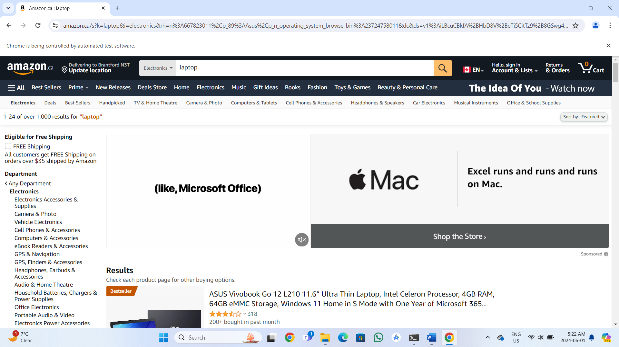 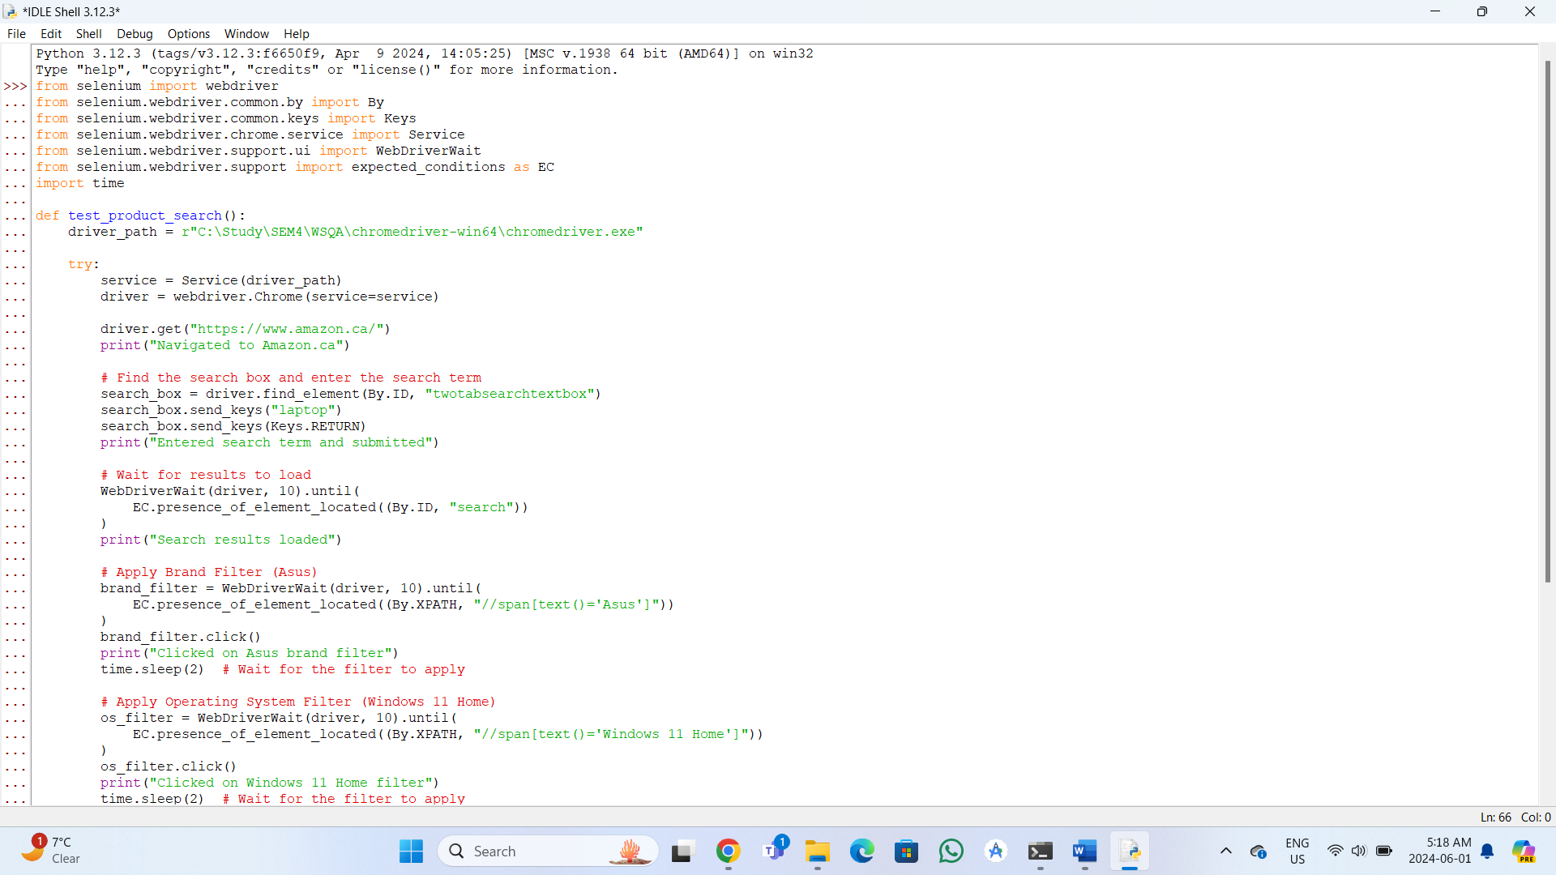

1. **Feature:** Add to Cart

**User Flow:**

* Navigate to a product page.
* Select product options (size, color, quantity).
* Click the "Add to Cart" button.
* Confirm the product is added to the cart.
* View the cart to verify the product and details.

**Test Case:**

* Test Plan: Use equivalence partitioning to test the add to cart functionality.
* Partitions: Valid products, invalid products (out of stock, unavailable options).

**Steps:**

* Add a valid product to the cart and verify it is added correctly.
* Try adding an out-of-stock product and verify the error message.
* Change product options and ensure the cart updates correctly.

**Add to Cart: Automated Test script:**

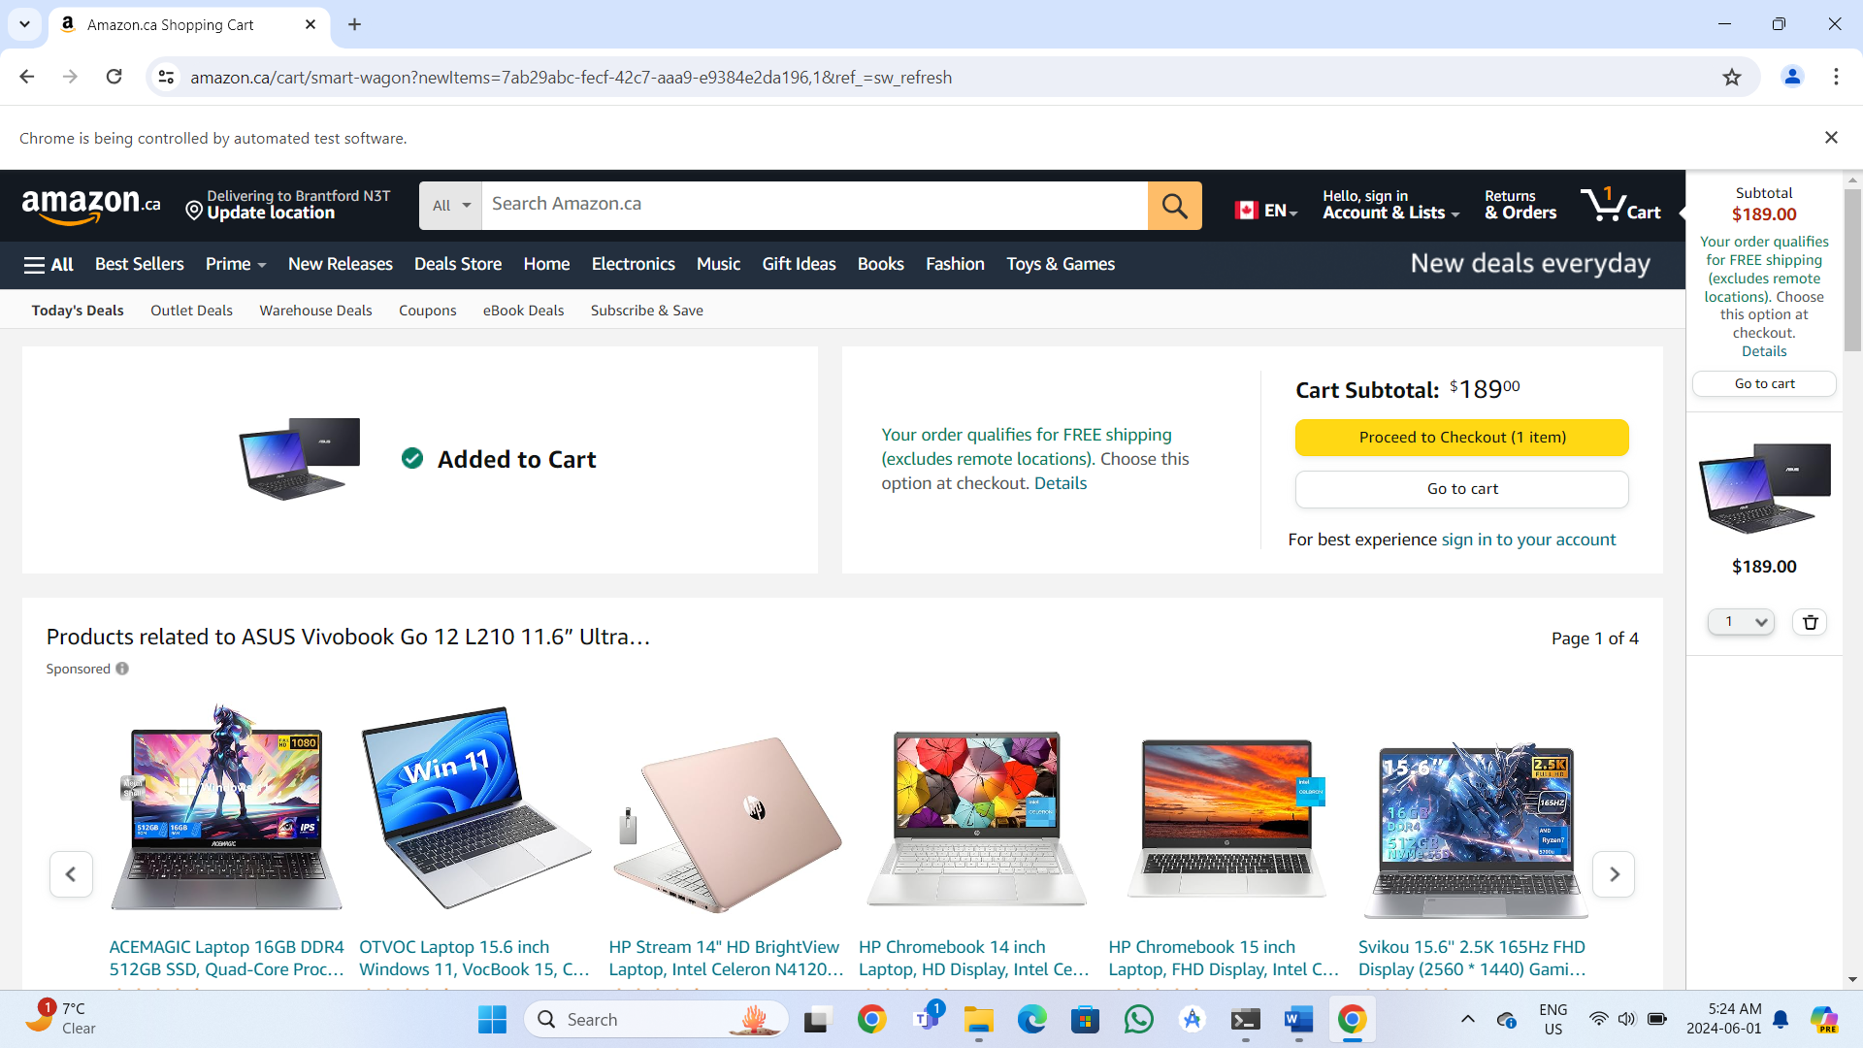 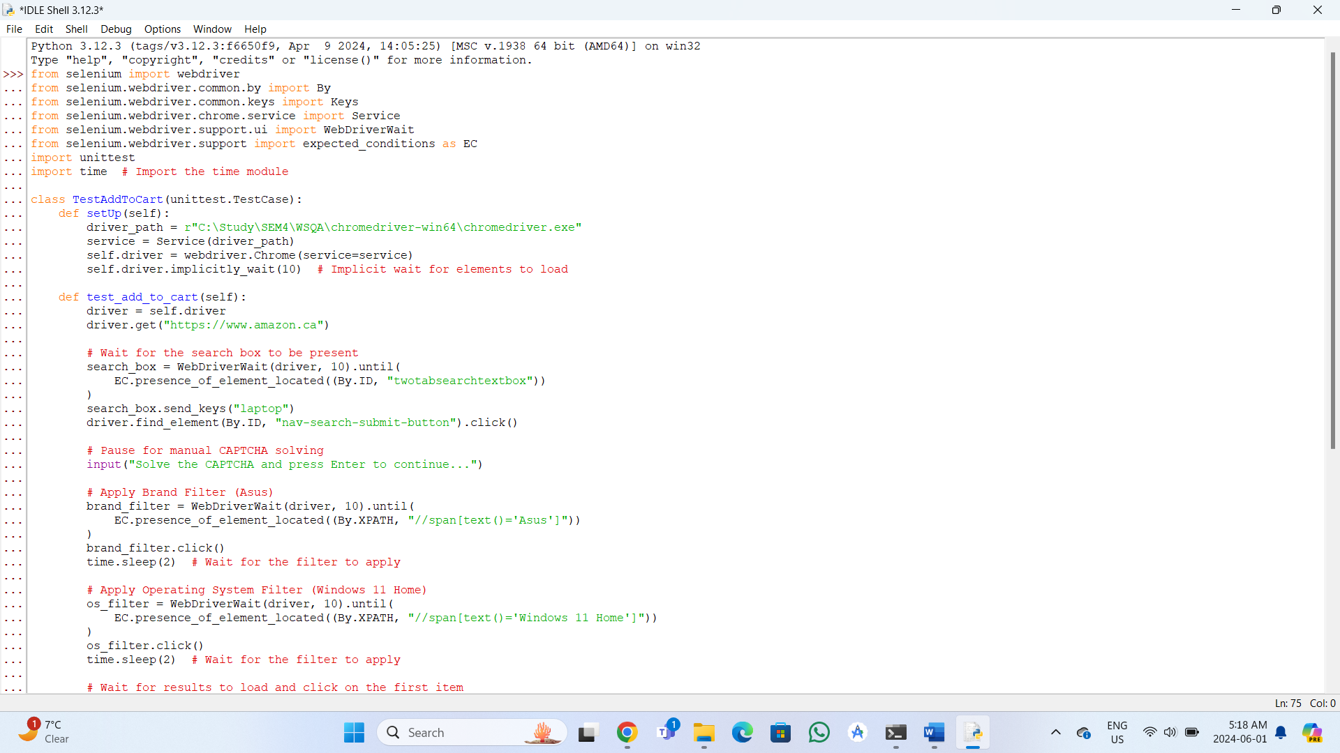

1. **Feature:** User Login

**User Flow:**

* Navigate to the login page.
* Enter the registered email and password.
* Click the login button.
* Redirect to the user's account dashboard.

**Test Case:**

* Test Plan: Use decision table testing for login functionality.
* Inputs: Email, Password.
* Decisions: Correct/incorrect email, correct/incorrect password.

**Steps:**

* Enter valid credentials and verify successful login.
* Enter invalid credentials and verify error messages.
* Test for locked account after multiple failed attempts.

**User Login:**

1. **Feature:** Checkout Process

**User Flow:**

* View the cart and proceed to checkout.
* Enter shipping information.
* Choose a payment method.
* Review the order summary.
* Confirm and place the order.

**Test Case:**

* Test Plan: Use scenario testing for the checkout process.
* Scenarios: Valid order, invalid shipping info, invalid payment method.

**Steps:**

* Complete the checkout process with valid details and verify order confirmation.
* Enter invalid shipping information and verify error message.
* Enter invalid payment details and verify error message.

**Checkout:**

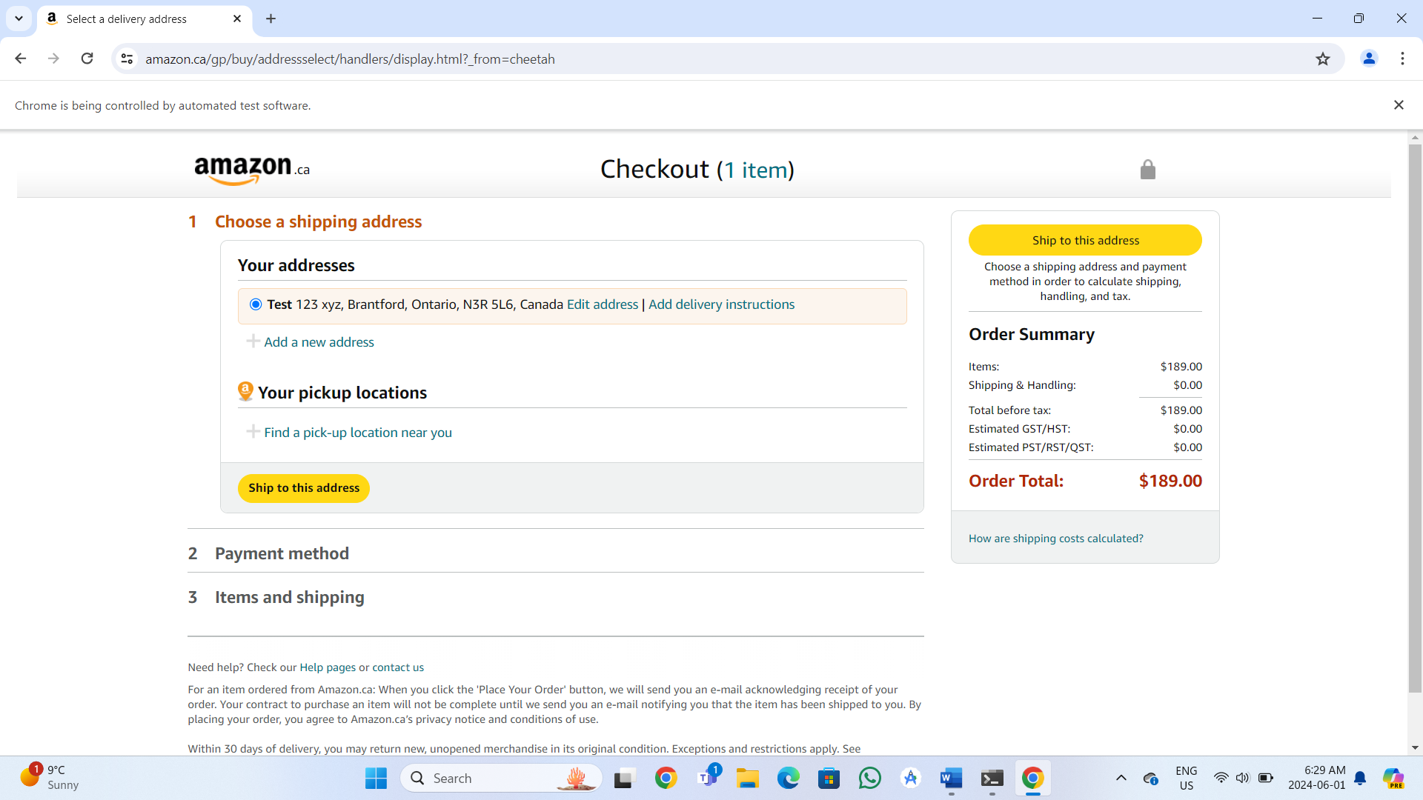

**Expected vs. Actual Results Table:**

